PUBLICITY CONTACTS:
Stephanie Mendoza | 212.698.2109
Stephanie.Mendoza@simonandschuster.com

Alison Hinchcliffe | 212.698.7090
Alison.Hinchcliffe@simonandschuster.com

Crystal Patriarche | 480.650.1688
crystal@BookSparksPR.com

“Witty, sexy.”
– LA Times

“A touching read women everywhere can find a way to relate to.”
– PopSugar

“A compelling, thoughtful take on a very real women’s health issue;
both confidently sexy and lighthearted at the same time.”
– Kirkuks Reviews
“Wonderfully eye opening, clearly well researched, and handled delicately,
this is sure to make summer a little hotter.”
– Library Journal

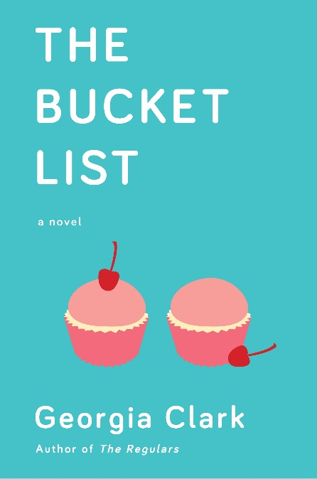
THE BUCKET LIST
a novel
Georgia Clark

From the author of the critically acclaimed “lively and engrossing parable for women of all generations” (Harper’s Bazaar) The Regulars comes the story of a young woman who, after discovering she has the “breast cancer gene,” embarks on an unforgettable bucket list adventure.

Twenty-five-year-old Lacey Whitman is very, very busy. She’s juggling two fabulous careers in NYC, is very single, very social, and has big plans for her future. The last thing she expects to find out after a routine check-up is that she’s the next Angelina Jolie, and not in a good way. Lacey’s inherited the breast cancer gene. She’s got two choices: watch and wait, or say goodbye to her breasts, forever. It’s a choice no woman wants to make, and yet so many of them must each year.
In Lacey’s opinion, her breasts have hardly gotten to first base, much less hit a home run. Partly as a coping mechanism, partly as a way to take back some control of her life, Lacey and her friends create a bucket list: everything she wants to do with and for her breasts before a possible surgery. Thus begins the most emotional and exhilarating year of her life: one of self-exploration that’ll help her grow up, fall in love, and define her relationship to herself and to her body. Both were things she thought she had a handle on, but now she’s learning that letting go a little might give her the future she really wants.
This is one bucket list you’ll never forget.

With her “compulsively delicious and refreshingly sexy” (Redbook) style, Clark shows a woman’s journey to true self-acceptance in a brilliant new novel that’ll make you laugh, cry, swoon, and think. GEORGIA CLARK is a novelist, screenwriter, and performer living in New York City. She’s the author of The Regulars and the YA novels She’s With The Band and Parched. She’s also the founder and host of the New York Times-recommended storytelling night Generation Women. A native Aussie, she lives in Brooklyn with her girlfriend and a fridge full of cheese.

PRAISE FOR THE REGULARS:

“[A] juicy fictional tale about three ordinary girls who have all of their wishes come true – and must ultimately deal with the consequences."

“If you adore stories of 20-somethings navigating the jungle of NYC, THE REGULARS is a compulsively delicious and refreshingly sexy dose of it.”
“[a] lively and engrossing parable for women of all generations,”

THE BUCKET LIST
A Novel
Georgia Clark
Emily Bestler Books/Atria
On-sale date: August 7, 2018; ISBN: 9781501173028; $26.00
Contacts: Stephanie Mendoza, 212-698-2109, Stephanie.Mendoza@simonandschuster.com
Alison Hinchcliffe, 212-698-7090, Alison.Hinchcliffe@simonandschuster.com
Crystal Patriarche, 480-650-1688, crystal@BookSparksPR.com

